No. | Answer
a n(C₆H₁₂O₆) = 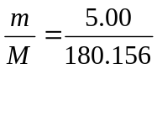 = 0.027 75
n(O) = 6 × n(C₆H₁₂O₆) = 6 × 0.027 75 = 0.166 mol
b n(H₂O₂) = 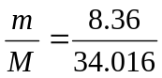 = 0.2458 mol
n(atoms) = 4 × n(H₂O₂) = 4 × 0.2458 = 0.9832
N(atoms) = n × N_{A} = 0.9832 × 6.022 × 10²³ = 5.92 × 10²³
c₁ × V₁ = c₂ × V₂, ∴ V₂ = 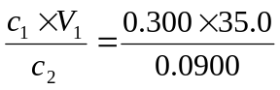 = 116.7 mL
∴ V(H₂O) added = 116.7 – 35.0 = 81.7 mL
 | pV = nRT ∴ p = 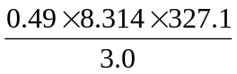 = 4.4 × 10² kPa
 | Mass of 1 mole = 4 × 10^{–22} × 6.022 × 10²³ = 2 × 10² g
 | pV = nRT and n = 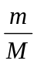 ∴ pV = RT ∴ V = 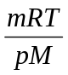 = 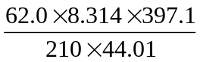 = 22.1 L
c(NaCl) = 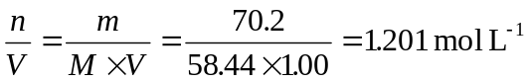
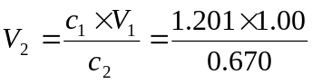 = 1.79 L
∴ 1.79 – 1.00 = 0.79 L of water must be added.
pV = nRT and n = ∴ pV = RT ∴ M = 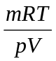 = 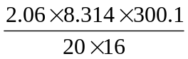 = 16 g mol^{–1}
The gas is methane.
 | Mass of ammonia = 1.50% of 150 mL = × 150 = 2.25 g
pV = 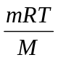 ∴ M = 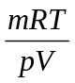 = 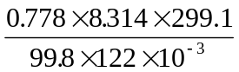 = 159 g mol^{–1}
The halogen must be bromine (Br₂).
600 ppm = 600 mg in 1.0 kg = 0.600 g in 1000 g = 0.0600 g of Hg in 100 g of water
n(Hg) = = 2.991 × 10^{–4} mol
n(Hg atoms) = 2.991 × 10^{–4} × 6.022 × 10²³ = 1.80 × 10²⁰ atoms
n(Pb(NO₃)₂) = 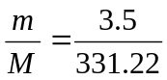 = 0.0106 mol
c(Pb(NO₃)₂) = 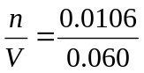 = 0.177 mol L^{–1}
c₂ = 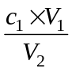 = 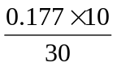 = 0.059 mol L^{–1}
c₂ = = 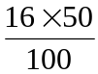 = 8.0% m/v
8.0% m/v = 8.0 g/100 mL = 80 g L^{–1} = 80 000 mg L^{–1}
Assuming the density of the water is 1 g mL^{–1} = 1 kg L^{–1}
Therefore, the concentration is 80 000 mg per 1 kg of solution = 8.0 × 10⁴ ppm.

a 2.33 g in 398 mL of water.
Assuming the density of the solution is 1 g mL^{–1}, the volume of the solution is also 398 mL.
% m/v = x 100 = 0.585%
b n(AgNO₃) = 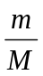 = 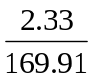 = 0.01371 mol
c(AgNO₃) = 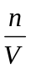 = 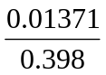 = 3.44 × 10^{–2} mol L^{–1}

